FLY AWAY DOCUMENTATION

Author & Developer: Mert Sever

Table Of Contents

1. Brief Explanation

2. Flow Charts Of Code

3. List of Core Concepts

4. Appendix

1. **Brief explanation:**

This web service has several capabilities, you can browse into website.

**Searching For Flight**

You can search a flight with information of source,destination,date and members. Just be carefull with date. its format mm/dd/yyyy.

**Booking a Flight**

You can book the flight that you just searched for! Press book button on related flight information row and it will lead you payment section! If everything was okay for you, just press the pay now! button.

**Admin Panel**

An admin can see all the flights with source,dest and price info. Admin can see all unique airlines as a list.

Admin can change his/her password anytime he/she wants!

**Enjoy your Travel!**

**Your Holidays are rezerved with Flyaway.com !**

1. **Flow Charts Of Code**

**2.1) Flow Chart For Search Algorithm**

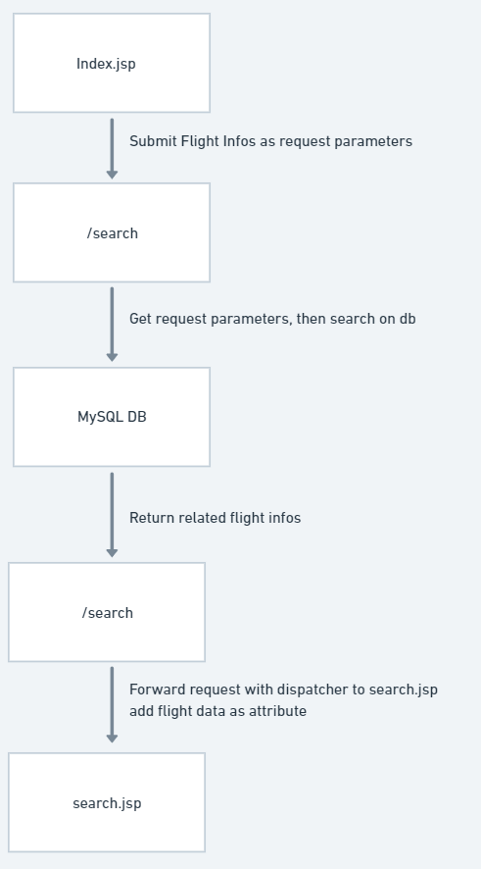

1. **List Of Core Consepts**

**1** - Tomcat

**2** - Hibernate

**3** - Java Servlets

**4** - Jsp

**5** - Sql

1. **Appendix**

**Flyaway admin info :** mail: [admin@flywaway.com](mailto:admin@flywaway.com) password: adminf

**Github Link :** https://github.com/etilmetileter/assesment2-Flyaway